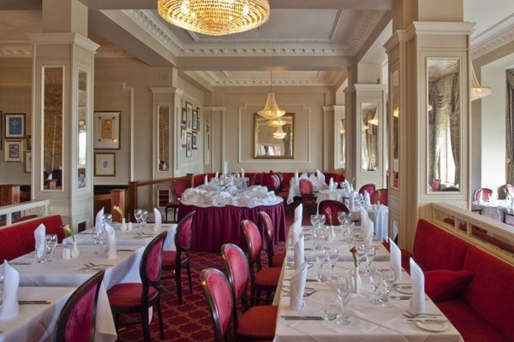

STARTERS

         Tomato and basil soup with green pesto crouton

        Confit duck salad with pancetta, watercress and a sweet chilli dressing

         Smooth chicken liver parfait, toasted buttery brioche, with a caramelised red onion chutney

MAINS

         Pan roasted chicken supreme, garden pea and pancetta finished with a tarragon sauce

         Slow braised feather blade of beef with a roasted shallot gravy

         French goats cheese layered with roasted vegetables and served on a creamy, spinach and white wine sauce

DESSERTS

         Warmed sticky toffee pudding finished with salted caramel sauce and vanilla ice cream

         White chocolate and raspberry cheesecake with fresh seasonal fruit

         Apple and rhubarb under an oaty baked crumble served with a traditional custard sauce

**If you have any dietary requirements, eg: gluten free, diabetic etc, please include this information so we can ensure these are catered for.**

The Chairman of Bournemouth East Conservative Association, Malcolm Davies, would like to personally invite you to A

**BECA ANNUAL SPEAKER DINNER**

**Friday 3rd November**

**7 for 7:30pm arrival**

**Guest Speaker: Lord Jeffrey Archer**

**THIS WILL BE HOSTED AT THE CARLTON HOEL**

**GROVE RD, BH1 3DN**

£40 per head with all proceeds going to BECA

Price includes a welcome drink on arrival, 3 course meal, and teas and coffees afterwards. Tickets for the Raffle will be available on the night, and the infamous BECA auction will also be going ahead!

Please contact the BECA office on: 01202 397047 or emailing bournemoutheastconservatives@gmail.com